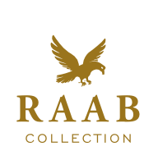

A Passion for History, An Eye for the Exceptional

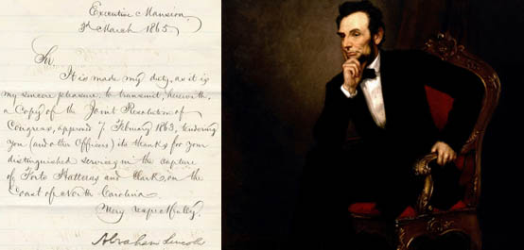
President Abraham Lincoln Original Signed Proclamation Conveying the Coveted “Thanks of Congress” to the Commodore Whose Victory in 1861 Led to the First Raising of the U.S. Flag Over a Confederate fortification in the Civil War

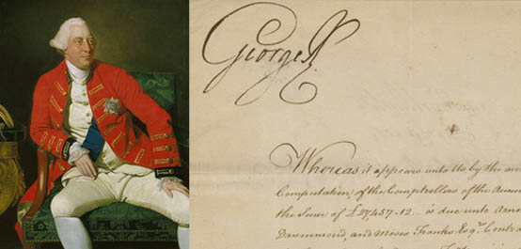
King George III Finances His Efforts Against the Colonists in the American Revolution…

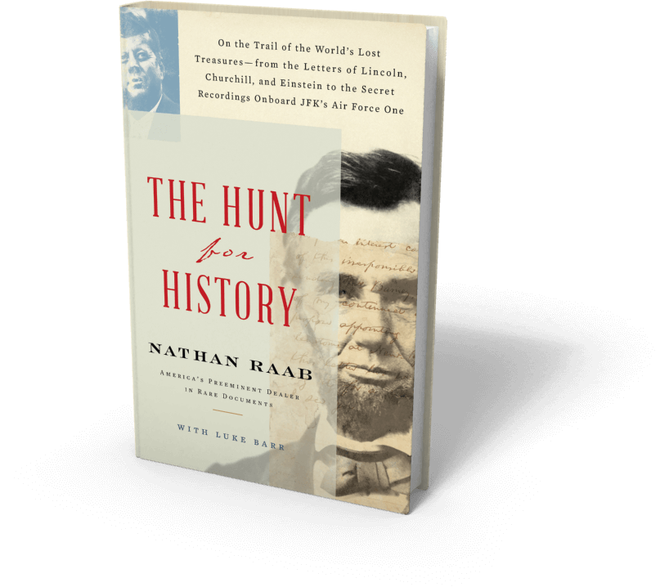

**receiving pre-release praise**
Nathan Raabs’ new book – March 2020
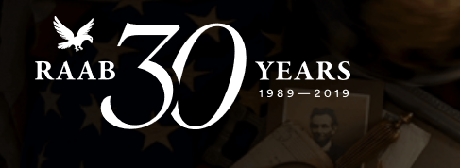

800-977- 8333 www.raabcollection.com

